1-How many Services exist on the system?

-K get svc

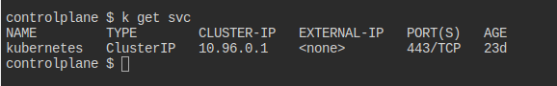

--------
2-What is the type of the default kubernetes service?

clusterip

--------
3-What is the targetPort configured on the kubernetes service?
k describe svc

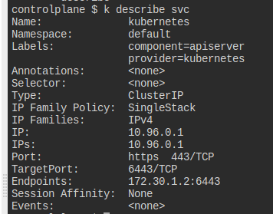

The port that I want to access targetport 6443/tcp
---------
4-How many labels are configured on the kubernetes service?

2 labels
component :apiserver
provider :kubernates

-------
5-How many Endpoints are attached on the kubernetes service?

1 endpoints :172.30.1.2:6643

-----------
6-Create a Deployment using the below yaml

apiVersion: apps/v1
kind: Deployment
metadata:
name: simple-webapp-deployment
namespace: default
spec:
replicas: 4
selector:
matchLabels:
name: simple-webapp
strategy:
rollingUpdate:
maxSurge: 25%
maxUnavailable: 25%
type: RollingUpdate
template:
metadata:
creationTimestamp: null
labels:
name: simple-webapp
spec:
containers:
- image: kodekloud/simple-webapp:red
imagePullPolicy: IfNotPresent
name: simple-webapp
ports:
- containerPort: 8080
protocol: TCP

-kubectl apply -f my-first-deployment\ .yaml

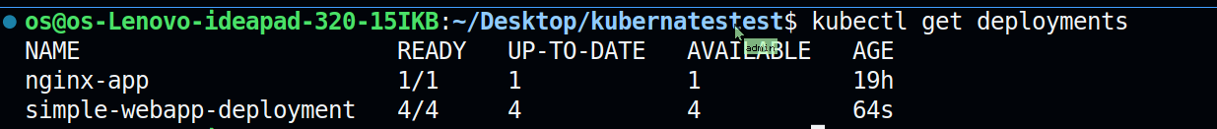

----------------
7-What is the image used to create the pods in the deployment?

- image: kodekloud/simple-webapp:red

------------
8-Create a new service to access the web application using the the below

Name: webapp-service
Type: NodePort
targetPort: 8080
port: 8080
nodePort: 30080
selector:
name: simple-webapp
